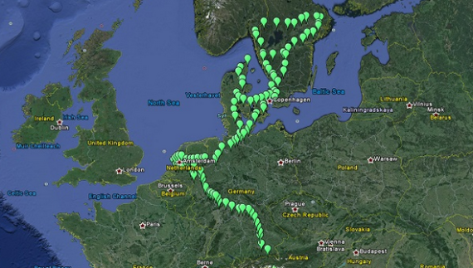he [**ELECTRIC project**](https://cisr-sslvpn-out2.insa-lyon.fr/+CSCO+0h756767633A2F2F7661726E2E72702E72686562636E2E7268++/download/project_fiches/multi_country/fichenew_2013eu92043s_final.pdf) is a consortium of five utilities and EV-focused organizations led by ABB, and it’s planning to install 155 ABB Terra Series EV chargers across the four Northern European countries by December 2015. The open-access network will ultimately include 67 chargers in Germany, 35 in Sweden, up to 30 in the [**Netherlands**](https://cisr-sslvpn-out2.insa-lyon.fr/+CSCO+0h756767633A2F2F7079726E61677270756176706E2E70627A++/2014/11/27/netherlands-europes-hub-e-vehicles/), and 23 in Denmark.

ELECTRIC’s EV charging investment is significant – $10.5 million, and it’s co-funded at a 50% level by the European Union’s [**Trans-European Transport Networks**](https://cisr-sslvpn-out2.insa-lyon.fr/+CSCO+0h756767633A2F2F7661726E2E72702E72686562636E2E7268++/en/ten-t/ten-t_projects/ten-t_projects_by_country/multi_country/2013-eu-92043-s.htm) (TEN-T) initiative. The project is already underway – ABB began installing [**100 EV charging locations across Denmark**](https://cisr-sslvpn-out2.insa-lyon.fr/+CSCO+0h756767633A2F2F6A6A6A2E6E6F6F2E70627A++/cawp/seitp202/8cfa9a111c7581c0c1257da9003684cd.aspx) in 2013, and while this new announcement is significant, it could have an even greater impact down the road.

EV chargers along the ELECTRIC network will collect data to analyze technical performance and driver usage patterns during pilot phase assessing potential expansion to new locations. “Once we gather the facts and figures, we believe we can help dispel any so-called range anxiety,”[**blogged Crijn Bouman**](https://cisr-sslvpn-out2.insa-lyon.fr/+CSCO+0h756767633A2F2F6A6A6A2E6E6F6F2D706261697265666E67766261662E70627A++/2014/12/european-consortium-set-to-accelerate-cross-border-e-mobility/) of ABB’s electric vehicle charging infrastructure group. “If we plan infrastructure carefully, nobody need worry about getting stuck without a place to charge up their vehicles.”

<https://cisr-sslvpn-out2.insa-lyon.fr/+CSCO+00756767633A2F2F7079726E61677270756176706E2E70627A++/2014/12/24/is-europe-leaving-electric-vehicle-range-anxiety-behind/>

While the ELECTRIC project expansion plans are significant, they pale in comparison to what’s about to unfold in France. EV company Bollore, already behind Paris’ Autolib EV car-sharing system, recently announced plans to [**install 16,000 EV charging stations across the country**](https://cisr-sslvpn-out2.insa-lyon.fr/+CSCO+0h756767633A2F2F6A6A6A2E73656E61707232342E70627A++/en/20141208-paris-electric-car-infrastructure-go-nationwide/)by 2018. France is considering tax incentives for Bollore to build chargers on public highways, meaning the network could theoretically link to the TEN-T system.

The massive EV charging infrastructure expansion is expected to cost $186 million, and while the exact charging locations aren’t yet determined, Bollore CEO Vincent Bollore said in a radio interview the ultimate network would ensure “no one in France will be more than 40 kilometers (around 25 miles) from a charging station.”

[**France’s EV sales are increasing**](https://cisr-sslvpn-out2.insa-lyon.fr/+CSCO+0h756767633A2F2F7079726E61677270756176706E2E70627A++/2014/01/13/electric-vehicle-sales-increase-55-france/) fast, meaning more and more drivers are looking to power up. 25 miles is well within the given range of nearly every EV on the road today, so driver anxiety may switch from worrying about running out of juice to debating which station is most convenient.

<https://cisr-sslvpn-out2.insa-lyon.fr/+CSCO+00756767633A2F2F7661667671727269662E70627A++/chademo-reports-2501-charging-stations-worldwid/>

<https://cisr-sslvpn-out2.insa-lyon.fr/+CSCO+00756767633A2F2F6A6A6A2E70756E71727A622E70627A++/wp/blog/2013/01/06/346/>

<http://ac.els-cdn.com/S0968090X15000303/1-s2.0-S0968090X15000303-main.pdf?_tid=edda4cc2-0532-11e5-b134-00000aab0f26&acdnat=1432815380_04d70af03a970e4afec805eaf258edac>

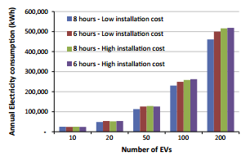

https://cisr-sslvpn-out2.insa-lyon.fr/+CSCO+00756767633A2F2F6F7962742E657A762E626574++/blog_2014_04_29_pulling_back_the_veil_on_ev_charging_station_costs